While initially building the Platform Project, Neima Found that attempting to run Build Project in Vitis caused there to be a make files error in PWM and created warning in other files.

09:14:26 **** Build of project SolarMotorPlatform ****

buildplatform.bat 62955 SolarMotorPlatform

XSDB Server Channel: tcfchan#5

Building the BSP Library for domain - standalone_domain on processor microblaze_0

make --no-print-directory seq_libs

"Running Make include in microblaze_0/libsrc/bram_v4_5/src"

make -C microblaze_0/libsrc/bram_v4_5/src -s include "SHELL=CMD" "COMPILER=mb-gcc" "ASSEMBLER=mb-as" "ARCHIVER=mb-ar" "COMPILE

R_FLAGS= -O2 -c -mcpu=v11.0 -mlittle-endian -mxl-soft-mul" "EXTRA_COMPILER_FLAGS=-g -ffunction-sections -fdata-sections -Wall

-Wextra"

"Running Make include in microblaze_0/libsrc/cpu_v2_12/src"

make -C microblaze_0/libsrc/cpu_v2_12/src -s include "SHELL=CMD" "COMPILER=mb-gcc" "ASSEMBLER=mb-as" "ARCHIVER=mb-ar" "COMPILE

R_FLAGS= -O2 -c -mcpu=v11.0 -mlittle-endian -mxl-soft-mul" "EXTRA_COMPILER_FLAGS=-g -ffunction-sections -fdata-sections -Wall

-Wextra"

"Running Make include in microblaze_0/libsrc/gpio_v4_7/src"

make -C microblaze_0/libsrc/gpio_v4_7/src -s include "SHELL=CMD" "COMPILER=mb-gcc" "ASSEMBLER=mb-as" "ARCHIVER=mb-ar" "COMPILE

R_FLAGS= -O2 -c -mcpu=v11.0 -mlittle-endian -mxl-soft-mul" "EXTRA_COMPILER_FLAGS=-g -ffunction-sections -fdata-sections -Wall

-Wextra"

"Running Make include in microblaze_0/libsrc/intc_v3_12/src"

make -C microblaze_0/libsrc/intc_v3_12/src -s include "SHELL=CMD" "COMPILER=mb-gcc" "ASSEMBLER=mb-as" "ARCHIVER=mb-ar" "COMPIL

ER_FLAGS= -O2 -c -mcpu=v11.0 -mlittle-endian -mxl-soft-mul" "EXTRA_COMPILER_FLAGS=-g -ffunction-sections -fdata-sections -Wall

-Wextra"

"Running Make include in microblaze_0/libsrc/nexys4io_v1_0/src"

make -C microblaze_0/libsrc/nexys4io_v1_0/src -s include "SHELL=CMD" "COMPILER=mb-gcc" "ASSEMBLER=mb-as" "ARCHIVER=mb-ar" "COM

PILER_FLAGS= -O2 -c -mcpu=v11.0 -mlittle-endian -mxl-soft-mul" "EXTRA_COMPILER_FLAGS=-g -ffunction-sections -fdata-sections -W

all -Wextra"

"Running Make include in microblaze_0/libsrc/PmodENC544_v1_0/src"

make -C microblaze_0/libsrc/PmodENC544_v1_0/src -s include "SHELL=CMD" "COMPILER=mb-gcc" "ASSEMBLER=mb-as" "ARCHIVER=mb-ar" "C

OMPILER_FLAGS= -O2 -c -mcpu=v11.0 -mlittle-endian -mxl-soft-mul" "EXTRA_COMPILER_FLAGS=-g -ffunction-sections -fdata-sections

-Wall -Wextra"

"Running Make include in microblaze_0/libsrc/PmodENC_v1_0/src"

make -C microblaze_0/libsrc/PmodENC_v1_0/src -s include "SHELL=CMD" "COMPILER=mb-gcc" "ASSEMBLER=mb-as" "ARCHIVER=mb-ar" "COMP

ILER_FLAGS= -O2 -c -mcpu=v11.0 -mlittle-endian -mxl-soft-mul" "EXTRA_COMPILER_FLAGS=-g -ffunction-sections -fdata-sections -Wa

ll -Wextra"

"Running Make include in microblaze_0/libsrc/PmodOLEDrgb_v1_0/src"

make -C microblaze_0/libsrc/PmodOLEDrgb_v1_0/src -s include "SHELL=CMD" "COMPILER=mb-gcc" "ASSEMBLER=mb-as" "ARCHIVER=mb-ar" "

COMPILER_FLAGS= -O2 -c -mcpu=v11.0 -mlittle-endian -mxl-soft-mul" "EXTRA_COMPILER_FLAGS=-g -ffunction-sections -fdata-sections

-Wall -Wextra"

"Running Make include in microblaze_0/libsrc/PWM_v1_0/src"

make -C microblaze_0/libsrc/PWM_v1_0/src -s include "SHELL=CMD" "COMPILER=mb-gcc" "ASSEMBLER=mb-as" "ARCHIVER=mb-ar" "COMPILER

_FLAGS= -O2 -c -mcpu=v11.0 -mlittle-endian -mxl-soft-mul" "EXTRA_COMPILER_FLAGS=-g -ffunction-sections -fdata-sections -Wall -

Wextra"

"Running Make include in microblaze_0/libsrc/standalone_v7_3/src"

make -C microblaze_0/libsrc/standalone_v7_3/src -s include "SHELL=CMD" "COMPILER=mb-gcc" "ASSEMBLER=mb-as" "ARCHIVER=mb-ar" "C

OMPILER_FLAGS= -O2 -c -mcpu=v11.0 -mlittle-endian -mxl-soft-mul" "EXTRA_COMPILER_FLAGS=-g -ffunction-sections -fdata-sections

-Wall -Wextra"

"Running Make include in microblaze_0/libsrc/sysmon_v7_7/src"

make -C microblaze_0/libsrc/sysmon_v7_7/src -s include "SHELL=CMD" "COMPILER=mb-gcc" "ASSEMBLER=mb-as" "ARCHIVER=mb-ar" "COMPI

LER_FLAGS= -O2 -c -mcpu=v11.0 -mlittle-endian -mxl-soft-mul" "EXTRA_COMPILER_FLAGS=-g -ffunction-sections -fdata-sections -Wal

l -Wextra"

"Running Make include in microblaze_0/libsrc/tmrctr_v4_7/src"

make -C microblaze_0/libsrc/tmrctr_v4_7/src -s include "SHELL=CMD" "COMPILER=mb-gcc" "ASSEMBLER=mb-as" "ARCHIVER=mb-ar" "COMPI

LER_FLAGS= -O2 -c -mcpu=v11.0 -mlittle-endian -mxl-soft-mul" "EXTRA_COMPILER_FLAGS=-g -ffunction-sections -fdata-sections -Wal

l -Wextra"

"Running Make include in microblaze_0/libsrc/uartlite_v3_5/src"

make -C microblaze_0/libsrc/uartlite_v3_5/src -s include "SHELL=CMD" "COMPILER=mb-gcc" "ASSEMBLER=mb-as" "ARCHIVER=mb-ar" "COM

PILER_FLAGS= -O2 -c -mcpu=v11.0 -mlittle-endian -mxl-soft-mul" "EXTRA_COMPILER_FLAGS=-g -ffunction-sections -fdata-sections -W

all -Wextra"

"Running Make include in microblaze_0/libsrc/wdttb_v5_1/src"

make -C microblaze_0/libsrc/wdttb_v5_1/src -s include "SHELL=CMD" "COMPILER=mb-gcc" "ASSEMBLER=mb-as" "ARCHIVER=mb-ar" "COMPIL

ER_FLAGS= -O2 -c -mcpu=v11.0 -mlittle-endian -mxl-soft-mul" "EXTRA_COMPILER_FLAGS=-g -ffunction-sections -fdata-sections -Wall

-Wextra"

"Running Make libs in microblaze_0/libsrc/nexys4io_v1_0/src"

make -C microblaze_0/libsrc/nexys4io_v1_0/src -s libs "SHELL=CMD" "COMPILER=mb-gcc" "ASSEMBLER=mb-as" "ARCHIVER=mb-ar" "COMPIL

ER_FLAGS= -O2 -c -mcpu=v11.0 -mlittle-endian -mxl-soft-mul" "EXTRA_COMPILER_FLAGS=-g -ffunction-sections -fdata-sections -Wall

-Wextra"

"Compiling nexys4IO..."

mb-ar: creating ../../../lib/libxil.a

"Running Make libs in microblaze_0/libsrc/PmodENC544_v1_0/src"

make -C microblaze_0/libsrc/PmodENC544_v1_0/src -s libs "SHELL=CMD" "COMPILER=mb-gcc" "ASSEMBLER=mb-as" "ARCHIVER=mb-ar" "COMP

ILER_FLAGS= -O2 -c -mcpu=v11.0 -mlittle-endian -mxl-soft-mul" "EXTRA_COMPILER_FLAGS=-g -ffunction-sections -fdata-sections -Wa

ll -Wextra"

"Compiling PmodENC544"

PmodENC544.c: In function 'PMODENC544_initialize':

PmodENC544.c:23:20: warning: comparison between pointer and integer

23 | if (baseaddr_p == NULL) {

| ^~

PmodENC544_selftest.c: In function 'PMODENC544_Reg_SelfTest':

PmodENC544_selftest.c:53:59: warning: comparison of integer expressions of different signedness: 'u32' {aka 'long unsigned int'} and 'int' [-Wsign-compare]

53 | if ( PMODENC544_mReadReg (baseaddr, read_loop_index*4) != (read_loop_index+1)*READ_WRITE_MUL_FACTOR){

| ^~

PmodENC544_selftest.c:37:6: warning: unused variable 'Index' [-Wunused-variable]

37 | int Index;

| ^~~~~

"Running Make libs in microblaze_0/libsrc/PmodENC_v1_0/src"

make -C microblaze_0/libsrc/PmodENC_v1_0/src -s libs "SHELL=CMD" "COMPILER=mb-gcc" "ASSEMBLER=mb-as" "ARCHIVER=mb-ar" "COMPILE

R_FLAGS= -O2 -c -mcpu=v11.0 -mlittle-endian -mxl-soft-mul" "EXTRA_COMPILER_FLAGS=-g -ffunction-sections -fdata-sections -Wall

-Wextra"

"Compiling PmodENC..."

"Running Make libs in microblaze_0/libsrc/PmodOLEDrgb_v1_0/src"

make -C microblaze_0/libsrc/PmodOLEDrgb_v1_0/src -s libs "SHELL=CMD" "COMPILER=mb-gcc" "ASSEMBLER=mb-as" "ARCHIVER=mb-ar" "COM

PILER_FLAGS= -O2 -c -mcpu=v11.0 -mlittle-endian -mxl-soft-mul" "EXTRA_COMPILER_FLAGS=-g -ffunction-sections -fdata-sections -W

all -Wextra"

"Compiling PmodOLEDrgb..."

PmodOLEDrgb_selftest.c: In function 'PMODOLEDRGB_Reg_SelfTest':

PmodOLEDrgb_selftest.c:52:60: warning: comparison of integer expressions of different signedness: 'u32' {aka 'long unsigned int'} and 'int' [-Wsign-compare]

52 | if ( PMODOLEDRGB_mReadReg (baseaddr, read_loop_index*4) != (read_loop_index+1)*READ_WRITE_MUL_FACTOR){

| ^~

PmodOLEDrgb_selftest.c:36:6: warning: unused variable 'Index' [-Wunused-variable]

36 | int Index;

| ^~~~~

"Running Make libs in microblaze_0/libsrc/PWM_v1_0/src"

make -C microblaze_0/libsrc/PWM_v1_0/src -s libs "SHELL=CMD" "COMPILER=mb-gcc" "ASSEMBLER=mb-as" "ARCHIVER=mb-ar" "COMPILER_FL

AGS= -O2 -c -mcpu=v11.0 -mlittle-endian -mxl-soft-mul" "EXTRA_COMPILER_FLAGS=-g -ffunction-sections -fdata-sections -Wall -Wex

tra"

"Compiling PWM..."

PWM_selftest.c: In function 'PWM_Reg_SelfTest':

PWM_selftest.c:52:52: warning: comparison of integer expressions of different signedness: 'u32' {aka 'long unsigned int'} and 'int' [-Wsign-compare]

52 | if ( PWM_mReadReg (baseaddr, read_loop_index*4) != (read_loop_index+1)*READ_WRITE_MUL_FACTOR){

| ^~

PWM_selftest.c:36:6: warning: unused variable 'Index' [-Wunused-variable]

36 | int Index;

| ^~~~~

mb-ar: *.o: Invalid argument

make[2]: *** [Makefile:19: libs] Error 1

make[1]: *** [Makefile:46: microblaze_0/libsrc/PWM_v1_0/src/make.libs] Error 2

make: *** [Makefile:18: all] Error 2

Failed to build the bsp sources for domain - standalone_domain

Failed to generate the platform.

Reason: Failed to build the bsp sources for domain - standalone_domain

invoked from within

"::tcf::eval -progress {apply {{msg} {puts $msg}}} {tcf_send_command tcfchan#0 xsdb eval s es {{platform active SolarMotorPlatform; platform generate }}}"

(procedure "::tcf::send_command" line 4)

invoked from within

"tcf send_command $::xsdb::curchan xsdb eval s es [list "platform active $PLATFORM_NAME; platform generate $target"]"

invoked from within

"if { $iswindows == 1 } {

set XSDB_PORT [lindex $argv 0]

set PLATFORM_NAME [lindex $argv 1]

set arglen [llength $argv]

set lastind..."

(file "C:/Xilinx/Vitis/2020.2\scripts\vitis\util\buildplatform.tcl" line 11)

09:14:29 Build Finished (took 3s.187ms)

Neima found that using the Clean Project option for building the Platform Project allowed it to run without error.

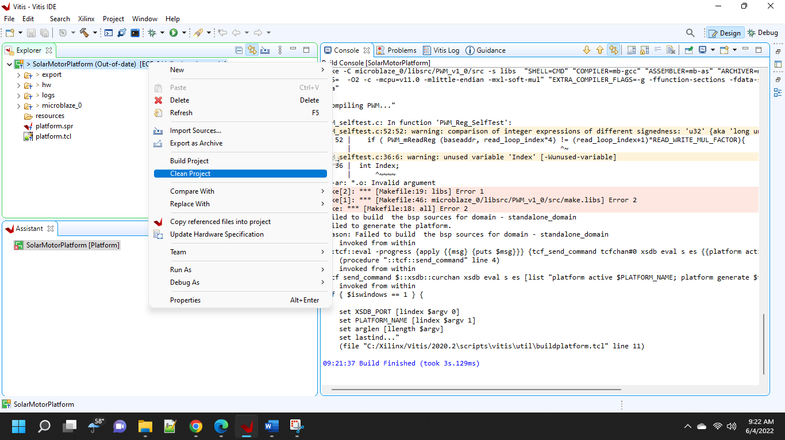

However these makefile problems seemed to caused a problem when attempting to make a new Application Project as the Platform Project was not available.

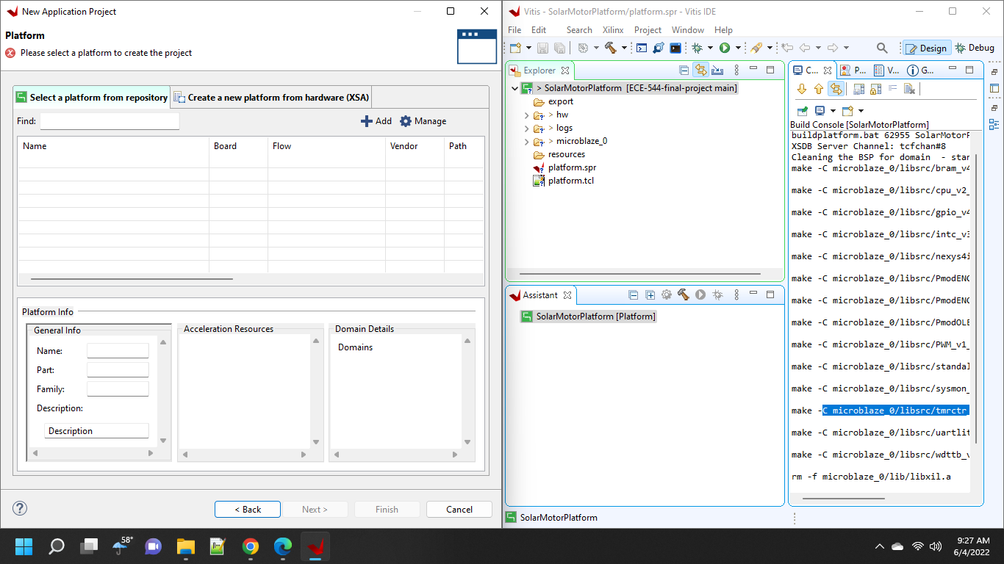

I tried linking the platform folder previously made with the Add option in the Select a Platform from repository screen but that did not cause it to appear in the list of platforms in repository.

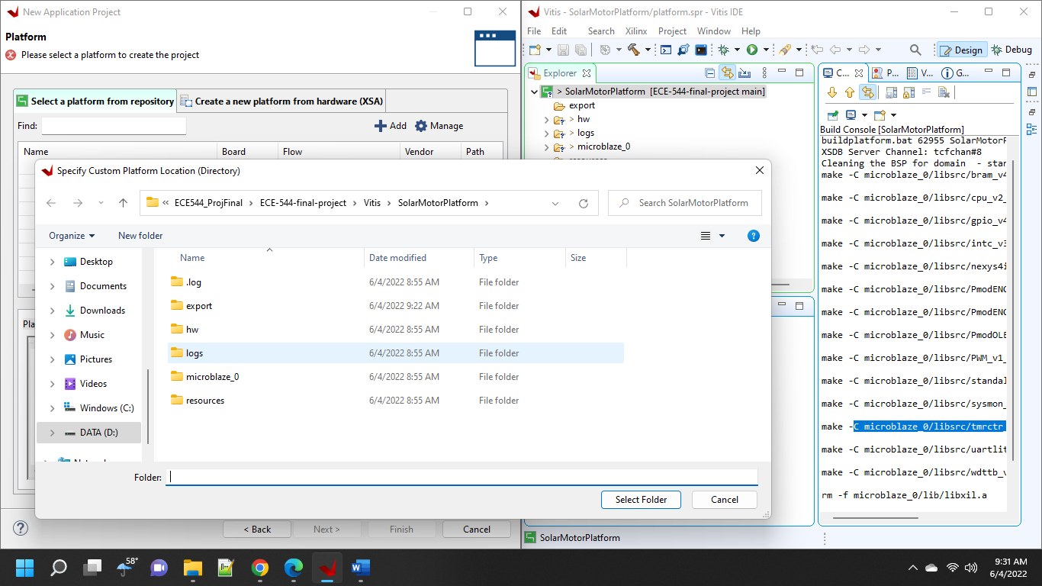

Project Plateform was still not avaliable

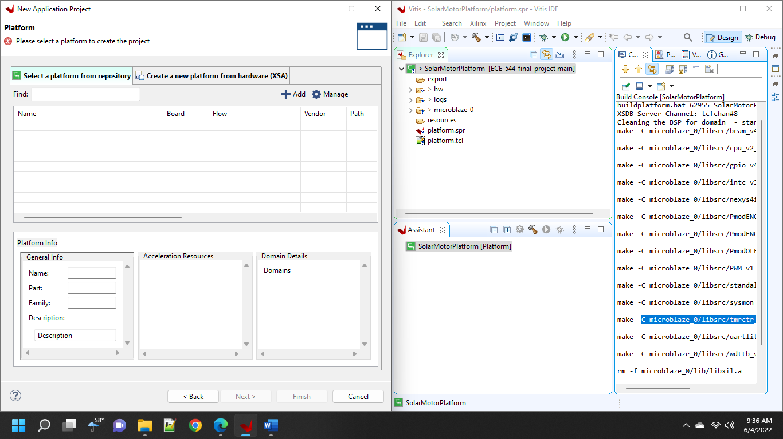

I then click the Manage button as was show a list of Folders. The First was an export folder within the folder for the Platform Project I had made while the second was the Folder I had just tried adding, which was the overall folder for that platform project. From that I concluded that the files I needed were supposed to be in the export folder. When I checked its content I saw that it was empty, which caused my current problem to start making sense. I thought this might mean “Clean Build” option did not actually solve my original problem with building the platform.

However looking in the export folder for my previously project 3 also showed it was empty so I am not sure what to conclude.

I am able to tell that the main error seems to be in the lib function of the make file for the PWM_v1_0 but that the include function of that file had previously worked.

I archived the make files and write some of it to be more in line the nexys4IO make file

Before Rewrite

After Rewrite

That actually seems to have worked and I was able to build the platform project. More importantly, the platform project was available when I tried to make an application project and there were files in the previously empty export folder. There were still 2 folders in the repository links for the platform repository in the application project builder which I did not expect.

This does not explain why that export folder had been empty in my project 3 folder.

I have successfully gotten the PWM Generator to output a PWM now